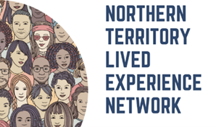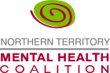

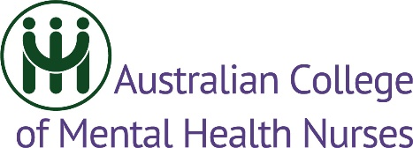

15TH August 2024

NT Mental Health Patients and Families stand side-by-side with Mental Health Nurses, Peak Bodies and Advocates to declare: “It’s just not good enough”

“Better Mental Health outcomes for Territorians means:
- More people working
- Families that function well
- Reduced impact on police and justice systems
Where are the commitment statements from 2024 election candidates to prioritise mental health and well-being of Territorians?”

For further comment contact:
Sam Goding
0487 823 478
sam@livedexperiencent.net
NT Lived Experience Network

